VURAM

QUESTIONS

**SUBMITTED BY:  
 S.Bala Soundharya**

**17BIT032**

**Q-1:**

**Package 1:**

package mypackage;

import java.util.Scanner;

import mypack.*;

public class MyPackage {

public static Scanner in = new Scanner(System.in);

public static void main(String[] args) {

int c,cc;

System.out.println("Pleace choose the type of service \n 1. prepaid \n 2. postpaid");

c = in.nextInt();

switch(c){

case 1:

{

prepaidPlan prepaid = new prepaidPlan();

System.out.println("please choose the mode of call \n 1. voice call \n 2. video call");

switch(in.nextInt()){

case 1:

{

System.out.println("Enter the no. of seconds for price");

System.out.println("cost for the call --> "+prepaid.voiceCall(in.nextInt()));

break;

}

case 2:

{

System.out.println("Enter the no. of seconds for price");

System.out.println("cost for the call --> "+prepaid.videoCall(in.nextInt()));

break;

}

}

}

case 2:

{

postpaidPlan postpaid = new postpaidPlan();

System.out.println("please choose the mode of call \n 1. voice call \n 2. video call");

switch(in.nextInt()){

case 1:

{

System.out.println("Enter the number of seconds");

System.out.println("Cost of the call is --> "+postpaid.voiceCall(in.nextInt()));

break;

}

case 2:

{

System.out.println("Enter the number of seconds");

System.out.println("Cost of the call is --> "+postpaid.videoCall(in.nextInt()));

break;

} }}}}}

**Package-2:**

package mypack;

public class prepaidPlan {

private float vc = 0.30f;

private float vidc = 1.00f;

public float voiceCall(int sec){

return sec * vc;

}

public float videoCall(int sec){

return sec * vidc;

}}

package mypack;

public class postpaidPlan {

private float vc = 0.10f;

private float vidc = 0.70f;

public float voiceCall(int sec){

return sec * vc;

}

public float videoCall(int sec){

return sec * vidc;

}}

**OUTPUT:**

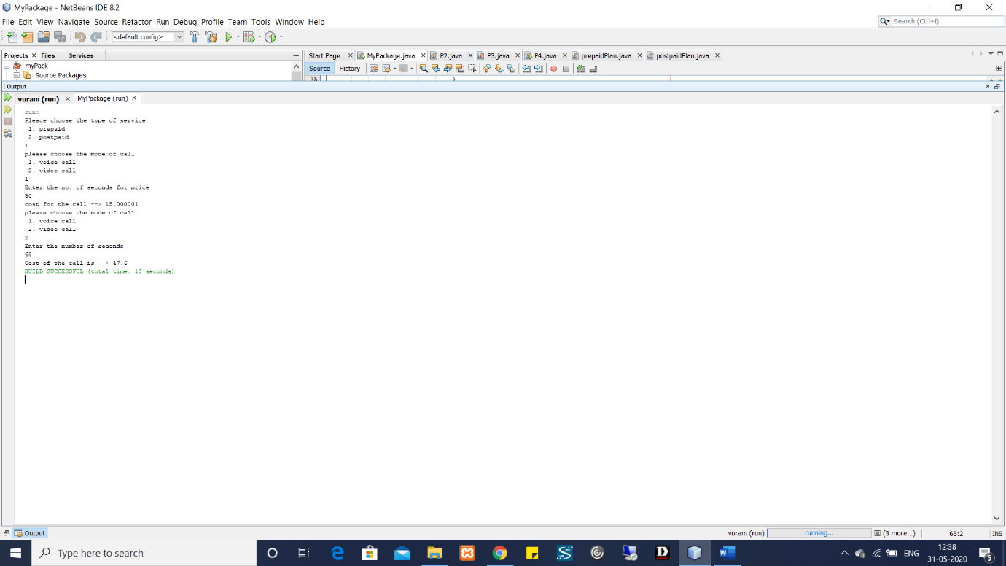

**Q-2:**

/*

* To change this license header, choose License Headers in Project Properties.

* To change this template file, choose Tools | Templates

* and open the template in the editor.

*/

package vuram;

import java.util.Scanner;

class InitialDepositException extends Exception{

public InitialDepositException() {

super("Initial Deposit must be greater than 3000 rupees");

}

}

public class P2 {

public static Scanner in = new Scanner(System.in);

public static void main(String[] args){

int amt;

System.out.println("Enter the amount for initial deposit");

try{

amt = in.nextInt();

if(amt < 3000){

throw new InitialDepositException();

}

else{

System.out.println("Susccessfuly deposited");

}

}

catch(InitialDepositException e){

System.out.println("Exception caught");

System.out.println(e.getMessage();

)

}

finally{

System.out.println("Thank you for using the service") }

}

OUTPUT:

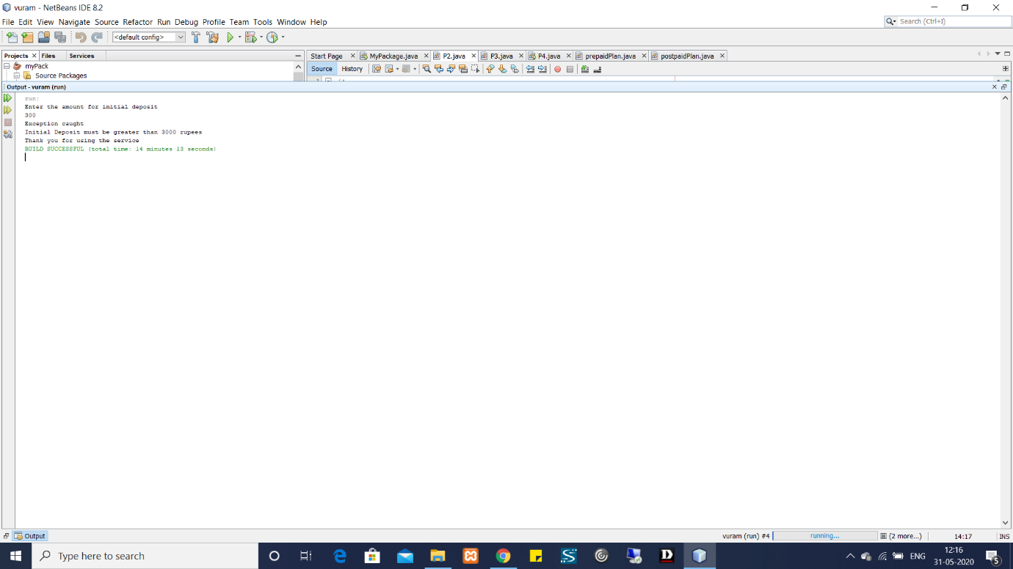

**Q-3:**

/*

* To change this license header, choose License Headers in Project Properties.

* To change this template file, choose Tools | Templates

* and open the template in the editor.

*/

package vuram;

import java.util.Scanner;

class Insurance {

public static int policy = 0;

public static int amt;

public static String name;

public static String id;

public Scanner in = new Scanner(System.in);

}

class PolicyCreation extends Insurance implements Runnable{

@Override

public void run(){

Create();

}

public void Create(){

try{

System.out.println("Enter the name of the policy holder to create");

name = in.nextLine();

System.out.println("Enter any identity number");

id = in.nextLine();

System.out.println("policy created");

policy = 1;

}catch(Exception e){

System.out.println(e);

}}}

class PremiumPayment extends PolicyCreation implements Runnable{

@Override

public void run(){

Pay();

}

public void Pay(){

System.out.println("Enter the amout to pay");

amt = in.nextInt();

System.out.println("Payment sucessfull !!!");

}}

class PolicyStatus extends PremiumPayment implements Runnable{

@Override

public void run(){

Status();

}

public void Status(){

if(policy == 0){

System.out.println("Policy does not exist");

}

else

System.out.println("Policy exists ");

}}

public class P3 {

public static void main(String[] args){

Scanner in = new Scanner(System.in);

int c;

PolicyCreation p = new PolicyCreation();

PremiumPayment pay = new PremiumPayment();

PolicyStatus ps = new PolicyStatus();

Thread t1 = new Thread(p);

Thread t2 = new Thread(pay);

Thread t3 = new Thread(ps);

t2.setPriority(Thread.MAX_PRIORITY);

t3.setPriority(Thread.MAX_PRIORITY);

while(true)

{

System.out.println("\n ----------------------------------------------------");

System.out.println("Enter the choice of action \n 1. Policy creation \n 2. premium payment \n 3. policy status \n 4. Exit");

System.out.println("\n ----------------------------------------------------");

c = in.nextInt();

switch(c){

case 1:{

t1.start();

try {

t1.join();

}catch(Exception e){

System.out.println("Thread overflow");

}

finally {

if(t1.isAlive()){

System.out.println("Policy creation still active");

}

else

System.out.println("Policy creation thread terminated");

}

break;

}

case 2:{

try{

t2.start();

t2.join();

}catch(Exception e){

System.out.println("Exception caught in premium payment");

}

break;

}

case 3:{

try{

t3.start();

t3.join();

}catch(Exception e){

System.out.println("Exception caught in policy status block");

}

break;

}

case 4:{

System.exit(c);

} }} }}

**OUTPUT:**

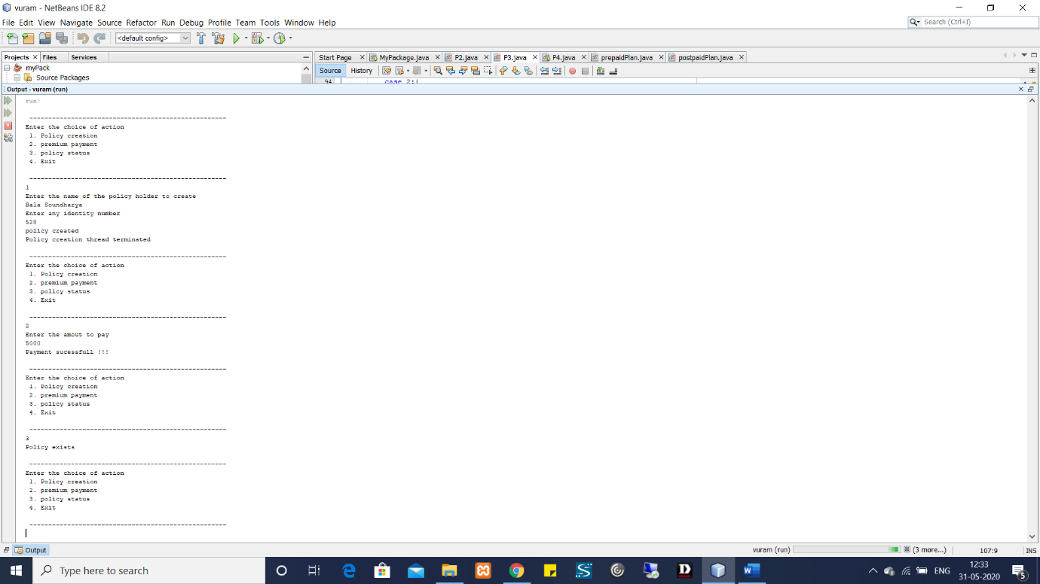

**Q-4:**

package vuram;

import java.io.DataInputStream;

import java.io.DataOutputStream;

import java.io.File;

import java.io.FileInputStream;

import java.io.FileOutputStream;

import java.io.Serializable;

import java.util.Scanner;

import org.omg.CORBA.Any;

import org.omg.CORBA.Object;

import org.omg.CORBA.TypeCode;

public class P4 {

static String Eno,E_name,Dept,dob,doj;

static String Employee_datail;

static int salary;

public static void main(String[] args) throws Exception{

Scanner s = new Scanner(System.in);

System.out.println("Enter Employee Details");

Eno = s.nextLine();

E_name = s.nextLine();

Dept = s.nextLine();

dob = s.nextLine();

doj = s.nextLine();

salary = s.nextInt();

Employee_datail = Eno+" \n"+E_name+" \n"+Dept+" \n"+dob+" \n"+doj+" \n"+salary+" \n";

write();

read();

}

private static void write() throws Exception{

File file = new File(Eno+".txt");

FileOutputStream fos = new FileOutputStream(file);

DataOutputStream dos = new DataOutputStream(fos);

dos.writeUTF(Employee_datail);

}

private static void read() throws Exception {

File file = new File(Eno+".txt");

FileInputStream fis = new FileInputStream(file);

DataInputStream dis = new DataInputStream(fis);

String detail = dis.readUTF();

System.out.println(detail);

}

}

**OUTPUT**:

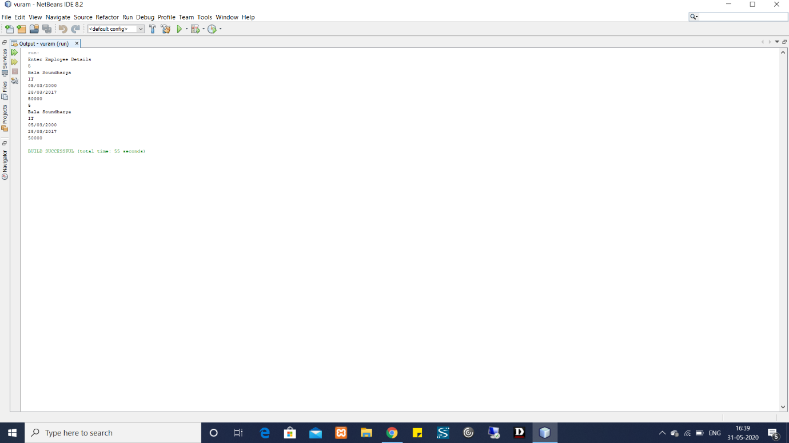

**Q-5:**

package vuram;

import com.sun.media.jfxmedia.logging.Logger;

public class P5 extends javax.swing.JApplet {

int num,factA;

@Override

public void init() {

/* Set the Nimbus look and feel */

//<editor-fold defaultstate="collapsed" desc=" Look and feel setting code (optional) ">

try {

for (javax.swing.UIManager.LookAndFeelInfo info : javax.swing.UIManager.getInstalledLookAndFeels()) {

if ("Nimbus".equals(info.getName())) {

javax.swing.UIManager.setLookAndFeel(info.getClassName());

break;

}

}

} catch (ClassNotFoundException ex) {

java.util.logging.Logger.getLogger(P5.class.getName()).log(java.util.logging.Level.SEVERE, null, ex);

} catch (InstantiationException ex) {

java.util.logging.Logger.getLogger(P5.class.getName()).log(java.util.logging.Level.SEVERE, null, ex);

} catch (IllegalAccessException ex) {

java.util.logging.Logger.getLogger(P5.class.getName()).log(java.util.logging.Level.SEVERE, null, ex);

} catch (javax.swing.UnsupportedLookAndFeelException ex) {

java.util.logging.Logger.getLogger(P5.class.getName()).log(java.util.logging.Level.SEVERE, null, ex);

}

//</editor-fold>

/* Create and display the applet */

try {

java.awt.EventQueue.invokeAndWait(new Runnable() {

public void run() {

initComponents();

}

});

} catch (Exception ex) {

ex.printStackTrace();

}

}

@SuppressWarnings("unchecked")

// <editor-fold defaultstate="collapsed" desc="Generated Code">//GEN-BEGIN:initComponents

private void initComponents() {

jLabel1 = new javax.swing.JLabel();

jLabel2 = new javax.swing.JLabel();

jTextField1 = new javax.swing.JTextField();

jLabel3 = new javax.swing.JLabel();

jLabel4 = new javax.swing.JLabel();

jButton1 = new javax.swing.JButton();

jButton2 = new javax.swing.JButton();

setMaximumSize(new java.awt.Dimension(429496729, 2147483647));

jLabel1.setFont(new java.awt.Font("Comic Sans MS", 0, 18)); // NOI18N

jLabel1.setHorizontalAlignment(javax.swing.SwingConstants.CENTER);

jLabel1.setText("FACTORIAL OF THE NUMBER");

jLabel2.setFont(new java.awt.Font("Arial", 0, 14)); // NOI18N

jLabel2.setText("Enter the number :");

jTextField1.addActionListener(new java.awt.event.ActionListener() {

public void actionPerformed(java.awt.event.ActionEvent evt) {

jTextField1ActionPerformed(evt);

}

});

jLabel3.setFont(new java.awt.Font("Arial", 0, 14)); // NOI18N

jLabel3.setText("Answer :");

jLabel4.setFont(new java.awt.Font("Arial", 0, 14)); // NOI18N

jButton1.setFont(new java.awt.Font("Comic Sans MS", 1, 14)); // NOI18N

jButton1.setText("Compute");

jButton1.addActionListener(new java.awt.event.ActionListener() {

public void actionPerformed(java.awt.event.ActionEvent evt) {

jButton1ActionPerformed(evt);

}

});

jButton2.setText("EXIT");

jButton2.addActionListener(new java.awt.event.ActionListener() {

public void actionPerformed(java.awt.event.ActionEvent evt) {

jButton2ActionPerformed(evt);

}

});

javax.swing.GroupLayout layout = new javax.swing.GroupLayout(getContentPane());

getContentPane().setLayout(layout);

layout.setHorizontalGroup(

layout.createParallelGroup(javax.swing.GroupLayout.Alignment.LEADING)

.addGroup(layout.createSequentialGroup()

.addGap(79, 79, 79)

.addGroup(layout.createParallelGroup(javax.swing.GroupLayout.Alignment.LEADING)

.addComponent(jLabel1, javax.swing.GroupLayout.PREFERRED_SIZE, 390, javax.swing.GroupLayout.PREFERRED_SIZE)

.addGroup(layout.createSequentialGroup()

.addComponent(jLabel3, javax.swing.GroupLayout.PREFERRED_SIZE, 84, javax.swing.GroupLayout.PREFERRED_SIZE)

.addPreferredGap(javax.swing.LayoutStyle.ComponentPlacement.RELATED)

.addComponent(jLabel4, javax.swing.GroupLayout.PREFERRED_SIZE, 68, javax.swing.GroupLayout.PREFERRED_SIZE))

.addGroup(layout.createSequentialGroup()

.addGroup(layout.createParallelGroup(javax.swing.GroupLayout.Alignment.LEADING)

.addGroup(layout.createSequentialGroup()

.addComponent(jLabel2, javax.swing.GroupLayout.PREFERRED_SIZE, 144, javax.swing.GroupLayout.PREFERRED_SIZE)

.addPreferredGap(javax.swing.LayoutStyle.ComponentPlacement.RELATED)

.addComponent(jTextField1, javax.swing.GroupLayout.PREFERRED_SIZE, 133, javax.swing.GroupLayout.PREFERRED_SIZE))

.addGroup(layout.createSequentialGroup()

.addGap(160, 160, 160)

.addComponent(jButton2, javax.swing.GroupLayout.PREFERRED_SIZE, 113, javax.swing.GroupLayout.PREFERRED_SIZE)))

.addGap(43, 43, 43)

.addComponent(jButton1)))

.addContainerGap(80, Short.MAX_VALUE))

);

layout.setVerticalGroup(

layout.createParallelGroup(javax.swing.GroupLayout.Alignment.LEADING)

.addGroup(layout.createSequentialGroup()

.addGap(21, 21, 21)

.addComponent(jLabel1, javax.swing.GroupLayout.PREFERRED_SIZE, 42, javax.swing.GroupLayout.PREFERRED_SIZE)

.addGap(73, 73, 73)

.addGroup(layout.createParallelGroup(javax.swing.GroupLayout.Alignment.BASELINE)

.addComponent(jLabel2)

.addComponent(jTextField1, javax.swing.GroupLayout.PREFERRED_SIZE, javax.swing.GroupLayout.DEFAULT_SIZE, javax.swing.GroupLayout.PREFERRED_SIZE)

.addComponent(jButton1))

.addGap(50, 50, 50)

.addGroup(layout.createParallelGroup(javax.swing.GroupLayout.Alignment.BASELINE)

.addComponent(jLabel3, javax.swing.GroupLayout.PREFERRED_SIZE, 27, javax.swing.GroupLayout.PREFERRED_SIZE)

.addComponent(jLabel4, javax.swing.GroupLayout.PREFERRED_SIZE, 27, javax.swing.GroupLayout.PREFERRED_SIZE))

.addPreferredGap(javax.swing.LayoutStyle.ComponentPlacement.RELATED, 32441, Short.MAX_VALUE)

.addComponent(jButton2)

.addGap(61, 61, 61))

);

}// </editor-fold>//GEN-END:initComponents

public int factorial(int n){

int fact = 1;

for(int i = 1 ; i <= n ; i++){

fact = fact * i;

}

return fact;

}

private void jTextField1ActionPerformed(java.awt.event.ActionEvent evt) {//GEN-FIRST:event_jTextField1ActionPerformed

// TODO add your handling code here:

}//GEN-LAST:event_jTextField1ActionPerformed

private void jButton1ActionPerformed(java.awt.event.ActionEvent evt) {//GEN-FIRST:event_jButton1ActionPerformed

// TODO add your handling code here:

try{

num = Integer.parseInt((jTextField1.getText()));

}

catch(Exception e){

System.out.println("invalid number");

}

factA = factorial(num);

jLabel4.setText(String.valueOf(factA));

}//GEN-LAST:event_jButton1ActionPerformed

private void jButton2ActionPerformed(java.awt.event.ActionEvent evt) {//GEN-FIRST:event_jButton2ActionPerformed

// TODO add your handling code here:

System.exit(1);

}//GEN-LAST:event_jButton2ActionPerformed

// Variables declaration - do not modify//GEN-BEGIN:variables

private javax.swing.JButton jButton1;

private javax.swing.JButton jButton2;

private javax.swing.JLabel jLabel1;

private javax.swing.JLabel jLabel2;

private javax.swing.JLabel jLabel3;

private javax.swing.JLabel jLabel4;

private javax.swing.JTextField jTextField1;

// End of variables declaration//GEN-END:variables

}

**OUTPUT:**

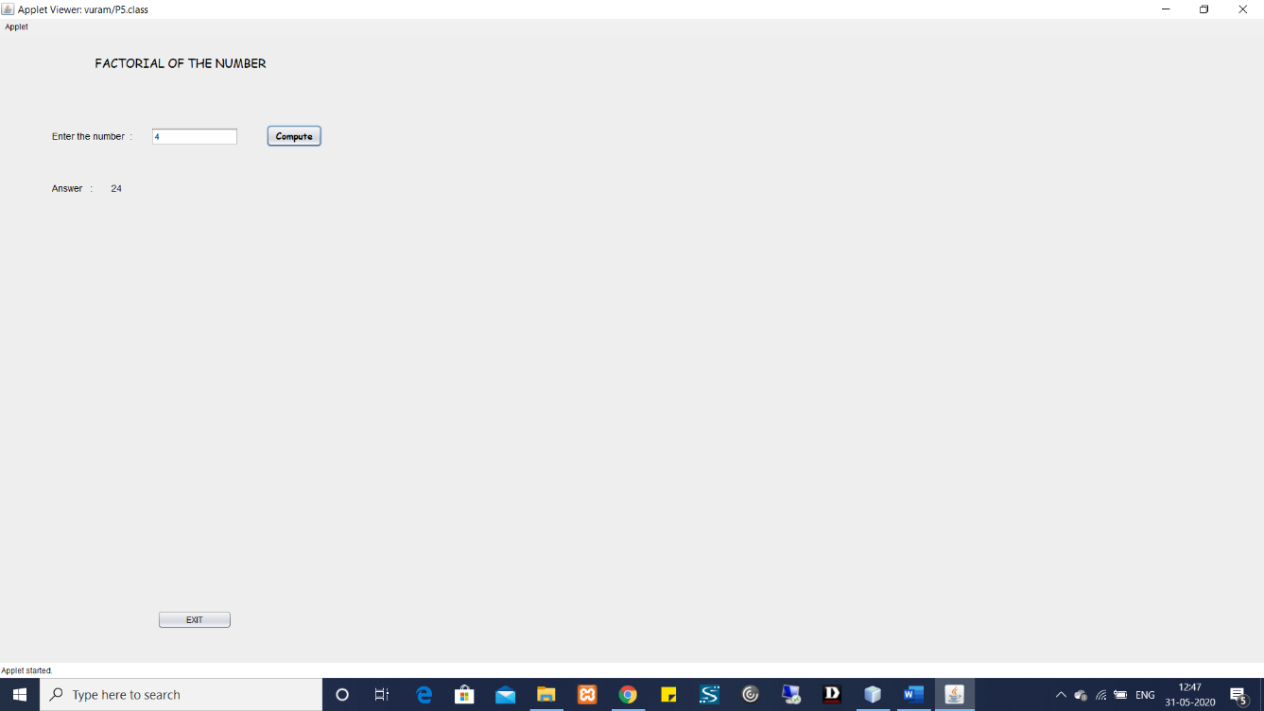

**Q-6:**

**package vuram;**

**public class P6 extends javax.swing.JApplet {**

**@Override**

**public void init() {**

**/* Set the Nimbus look and feel */**

**//<editor-fold defaultstate="collapsed" desc=" Look and feel setting code (optional) ">**

**/* If Nimbus (introduced in Java SE 6) is not available, stay with the default look and feel.**

**\* For details see http://download.oracle.com/javase/tutorial/uiswing/lookandfeel/plaf.html**

**\*/**

**try {**

**for (javax.swing.UIManager.LookAndFeelInfo info : javax.swing.UIManager.getInstalledLookAndFeels()) {**

**if ("Nimbus".equals(info.getName())) {**

**javax.swing.UIManager.setLookAndFeel(info.getClassName());**

**break;**

**}**

**}**

**} catch (ClassNotFoundException ex) {**

**java.util.logging.Logger.getLogger(P6.class.getName()).log(java.util.logging.Level.SEVERE, null, ex);**

**} catch (InstantiationException ex) {**

**java.util.logging.Logger.getLogger(P6.class.getName()).log(java.util.logging.Level.SEVERE, null, ex);**

**} catch (IllegalAccessException ex) {**

**java.util.logging.Logger.getLogger(P6.class.getName()).log(java.util.logging.Level.SEVERE, null, ex);**

**} catch (javax.swing.UnsupportedLookAndFeelException ex) {**

**java.util.logging.Logger.getLogger(P6.class.getName()).log(java.util.logging.Level.SEVERE, null, ex);**

**}**

**//</editor-fold>**

**/* Create and display the applet */**

**try {**

**java.awt.EventQueue.invokeAndWait(new Runnable() {**

**public void run() {**

**initComponents();**

**}**

**});**

**} catch (Exception ex) {**

**ex.printStackTrace();**

**}**

**}**

**@SuppressWarnings("unchecked")**

**// <editor-fold defaultstate="collapsed" desc="Generated Code">//GEN-BEGIN:initComponents**

**private void initComponents() {**

**jLabel1 = new javax.swing.JLabel();**

**jLabel2 = new javax.swing.JLabel();**

**jLabel3 = new javax.swing.JLabel();**

**jTextField1 = new javax.swing.JTextField();**

**jTextField2 = new javax.swing.JTextField();**

**jButton1 = new javax.swing.JButton();**

**jButton2 = new javax.swing.JButton();**

**jButton3 = new javax.swing.JButton();**

**jLabel4 = new javax.swing.JLabel();**

**jLabel5 = new javax.swing.JLabel();**

**jButton4 = new javax.swing.JButton();**

**setMinimumSize(new java.awt.Dimension(572, 440));**

**jLabel1.setFont(new java.awt.Font("Tahoma", 0, 18)); // NOI18N**

**jLabel1.setHorizontalAlignment(javax.swing.SwingConstants.CENTER);**

**jLabel1.setText("ARTHEMATIC OPERATIONS");**

**jLabel1.setToolTipText("");**

**jLabel2.setFont(new java.awt.Font("Tahoma", 0, 14)); // NOI18N**

**jLabel2.setText("NUM 1 :");**

**jLabel3.setFont(new java.awt.Font("Tahoma", 0, 14)); // NOI18N**

**jLabel3.setText("NUM 2 :");**

**jTextField1.addActionListener(new java.awt.event.ActionListener() {**

**public void actionPerformed(java.awt.event.ActionEvent evt) {**

**jTextField1ActionPerformed(evt);**

**}**

**});**

**jTextField2.addActionListener(new java.awt.event.ActionListener() {**

**public void actionPerformed(java.awt.event.ActionEvent evt) {**

**jTextField2ActionPerformed(evt);**

**}**

**});**

**jButton1.setText("+");**

**jButton1.addActionListener(new java.awt.event.ActionListener() {**

**public void actionPerformed(java.awt.event.ActionEvent evt) {**

**jButton1ActionPerformed(evt);**

**}**

**});**

**jButton2.setText("-");**

**jButton2.addActionListener(new java.awt.event.ActionListener() {**

**public void actionPerformed(java.awt.event.ActionEvent evt) {**

**jButton2ActionPerformed(evt);**

**}**

**});**

**jButton3.setText("*");**

**jButton3.addActionListener(new java.awt.event.ActionListener() {**

**public void actionPerformed(java.awt.event.ActionEvent evt) {**

**jButton3ActionPerformed(evt);**

**}**

**});**

**jLabel4.setFont(new java.awt.Font("Tahoma", 0, 14)); // NOI18N**

**jLabel4.setText("ANSWER :");**

**jLabel5.setFont(new java.awt.Font("Tahoma", 1, 14)); // NOI18N**

**jLabel5.setHorizontalAlignment(javax.swing.SwingConstants.CENTER);**

**jButton4.setText("EXIT");**

**jButton4.addActionListener(new java.awt.event.ActionListener() {**

**public void actionPerformed(java.awt.event.ActionEvent evt) {**

**jButton4ActionPerformed(evt);**

**}**

**});**

**javax.swing.GroupLayout layout = new javax.swing.GroupLayout(getContentPane());**

**getContentPane().setLayout(layout);**

**layout.setHorizontalGroup(**

**layout.createParallelGroup(javax.swing.GroupLayout.Alignment.LEADING)**

**.addGroup(javax.swing.GroupLayout.Alignment.TRAILING, layout.createSequentialGroup()**

**.addContainerGap(91, Short.MAX_VALUE)**

**.addComponent(jLabel1, javax.swing.GroupLayout.PREFERRED_SIZE, 373, javax.swing.GroupLayout.PREFERRED_SIZE)**

**.addGap(108, 108, 108))**

**.addGroup(layout.createSequentialGroup()**

**.addGap(101, 101, 101)**

**.addGroup(layout.createParallelGroup(javax.swing.GroupLayout.Alignment.LEADING, false)**

**.addComponent(jLabel3, javax.swing.GroupLayout.DEFAULT_SIZE, javax.swing.GroupLayout.DEFAULT_SIZE, Short.MAX_VALUE)**

**.addComponent(jLabel2, javax.swing.GroupLayout.DEFAULT_SIZE, javax.swing.GroupLayout.DEFAULT_SIZE, Short.MAX_VALUE)**

**.addComponent(jLabel4, javax.swing.GroupLayout.DEFAULT_SIZE, 67, Short.MAX_VALUE))**

**.addGap(47, 47, 47)**

**.addGroup(layout.createParallelGroup(javax.swing.GroupLayout.Alignment.LEADING)**

**.addGroup(layout.createSequentialGroup()**

**.addComponent(jButton4, javax.swing.GroupLayout.PREFERRED_SIZE, 89, javax.swing.GroupLayout.PREFERRED_SIZE)**

**.addContainerGap(javax.swing.GroupLayout.DEFAULT_SIZE, Short.MAX_VALUE))**

**.addGroup(layout.createSequentialGroup()**

**.addGroup(layout.createParallelGroup(javax.swing.GroupLayout.Alignment.LEADING, false)**

**.addComponent(jTextField2, javax.swing.GroupLayout.DEFAULT_SIZE, 71, Short.MAX_VALUE)**

**.addComponent(jTextField1)**

**.addComponent(jLabel5, javax.swing.GroupLayout.DEFAULT_SIZE, javax.swing.GroupLayout.DEFAULT_SIZE, Short.MAX_VALUE))**

**.addPreferredGap(javax.swing.LayoutStyle.ComponentPlacement.RELATED, javax.swing.GroupLayout.DEFAULT_SIZE, Short.MAX_VALUE)**

**.addGroup(layout.createParallelGroup(javax.swing.GroupLayout.Alignment.LEADING, false)**

**.addComponent(jButton3, javax.swing.GroupLayout.DEFAULT_SIZE, javax.swing.GroupLayout.DEFAULT_SIZE, Short.MAX_VALUE)**

**.addComponent(jButton1, javax.swing.GroupLayout.DEFAULT_SIZE, 56, Short.MAX_VALUE)**

**.addComponent(jButton2, javax.swing.GroupLayout.DEFAULT_SIZE, javax.swing.GroupLayout.DEFAULT_SIZE, Short.MAX_VALUE))**

**.addGap(94, 94, 94))))**

**);**

**layout.setVerticalGroup(**

**layout.createParallelGroup(javax.swing.GroupLayout.Alignment.LEADING)**

**.addGroup(layout.createSequentialGroup()**

**.addGap(50, 50, 50)**

**.addComponent(jLabel1, javax.swing.GroupLayout.PREFERRED_SIZE, 38, javax.swing.GroupLayout.PREFERRED_SIZE)**

**.addGap(57, 57, 57)**

**.addGroup(layout.createParallelGroup(javax.swing.GroupLayout.Alignment.BASELINE)**

**.addComponent(jLabel2, javax.swing.GroupLayout.PREFERRED_SIZE, 23, javax.swing.GroupLayout.PREFERRED_SIZE)**

**.addComponent(jTextField1, javax.swing.GroupLayout.PREFERRED_SIZE, javax.swing.GroupLayout.DEFAULT_SIZE, javax.swing.GroupLayout.PREFERRED_SIZE)**

**.addComponent(jButton1, javax.swing.GroupLayout.PREFERRED_SIZE, 41, javax.swing.GroupLayout.PREFERRED_SIZE))**

**.addGroup(layout.createParallelGroup(javax.swing.GroupLayout.Alignment.LEADING)**

**.addGroup(layout.createSequentialGroup()**

**.addGap(24, 24, 24)**

**.addGroup(layout.createParallelGroup(javax.swing.GroupLayout.Alignment.BASELINE)**

**.addComponent(jLabel3, javax.swing.GroupLayout.PREFERRED_SIZE, 27, javax.swing.GroupLayout.PREFERRED_SIZE)**

**.addComponent(jTextField2, javax.swing.GroupLayout.PREFERRED_SIZE, javax.swing.GroupLayout.DEFAULT_SIZE, javax.swing.GroupLayout.PREFERRED_SIZE)))**

**.addGroup(layout.createSequentialGroup()**

**.addGap(18, 18, 18)**

**.addComponent(jButton2, javax.swing.GroupLayout.PREFERRED_SIZE, 42, javax.swing.GroupLayout.PREFERRED_SIZE)))**

**.addGroup(layout.createParallelGroup(javax.swing.GroupLayout.Alignment.LEADING)**

**.addGroup(layout.createSequentialGroup()**

**.addGap(28, 28, 28)**

**.addComponent(jButton3, javax.swing.GroupLayout.PREFERRED_SIZE, 42, javax.swing.GroupLayout.PREFERRED_SIZE))**

**.addGroup(layout.createSequentialGroup()**

**.addGap(67, 67, 67)**

**.addGroup(layout.createParallelGroup(javax.swing.GroupLayout.Alignment.BASELINE)**

**.addComponent(jLabel4, javax.swing.GroupLayout.PREFERRED_SIZE, 29, javax.swing.GroupLayout.PREFERRED_SIZE)**

**.addComponent(jLabel5, javax.swing.GroupLayout.PREFERRED_SIZE, 29, javax.swing.GroupLayout.PREFERRED_SIZE))))**

**.addPreferredGap(javax.swing.LayoutStyle.ComponentPlacement.RELATED, 36, Short.MAX_VALUE)**

**.addComponent(jButton4, javax.swing.GroupLayout.PREFERRED_SIZE, 38, javax.swing.GroupLayout.PREFERRED_SIZE)**

**.addGap(24, 24, 24))**

**);**

**}// </editor-fold>//GEN-END:initComponents**

**private void jTextField1ActionPerformed(java.awt.event.ActionEvent evt) {//GEN-FIRST:event_jTextField1ActionPerformed**

**// TODO add your handling code here:**

**}//GEN-LAST:event_jTextField1ActionPerformed**

**private void jTextField2ActionPerformed(java.awt.event.ActionEvent evt) {//GEN-FIRST:event_jTextField2ActionPerformed**

**// TODO add your handling code here:**

**}//GEN-LAST:event_jTextField2ActionPerformed**

**private void jButton1ActionPerformed(java.awt.event.ActionEvent evt) {//GEN-FIRST:event_jButton1ActionPerformed**

**int n1,n2;**

**n1 = Integer.parseInt(jTextField1.getText());**

**n2 = Integer.parseInt(jTextField2.getText());**

**n1 = n1+n2;**

**jLabel5.setText(String.valueOf(n1));**

**}//GEN-LAST:event_jButton1ActionPerformed**

**private void jButton2ActionPerformed(java.awt.event.ActionEvent evt) {//GEN-FIRST:event_jButton2ActionPerformed**

**// TODO add your handling code here:**

**//button for subraction**

**int n1,n2;**

**n1 = Integer.parseInt(jTextField1.getText());**

**n2 = Integer.parseInt(jTextField2.getText());**

**n1 = n1-n2;**

**jLabel5.setText(String.valueOf(n1));**

**}//GEN-LAST:event_jButton2ActionPerformed**

**private void jButton3ActionPerformed(java.awt.event.ActionEvent evt) {//GEN-FIRST:event_jButton3ActionPerformed**

**// TODO add your handling code here:**

**//button for multiplication**

**int n1,n2;**

**n1 = Integer.parseInt(jTextField1.getText());**

**n2 = Integer.parseInt(jTextField2.getText());**

**n1 = n1*n2;**

**jLabel5.setText(String.valueOf(n1));**

**}//GEN-LAST:event_jButton3ActionPerformed**

**private void jButton4ActionPerformed(java.awt.event.ActionEvent evt) {//GEN-FIRST:event_jButton4ActionPerformed**

**// TODO add your handling code here:**

**System.exit(1);**

**}//GEN-LAST:event_jButton4ActionPerformed**

**// Variables declaration - do not modify//GEN-BEGIN:variables**

**private javax.swing.JButton jButton1;**

**private javax.swing.JButton jButton2;**

**private javax.swing.JButton jButton3;**

**private javax.swing.JButton jButton4;**

**private javax.swing.JLabel jLabel1;**

**private javax.swing.JLabel jLabel2;**

**private javax.swing.JLabel jLabel3;**

**private javax.swing.JLabel jLabel4;**

**private javax.swing.JLabel jLabel5;**

**private javax.swing.JTextField jTextField1;**

**private javax.swing.JTextField jTextField2;**

**// End of variables declaration//GEN-END:variables**

**}**

**OUTPUT:**

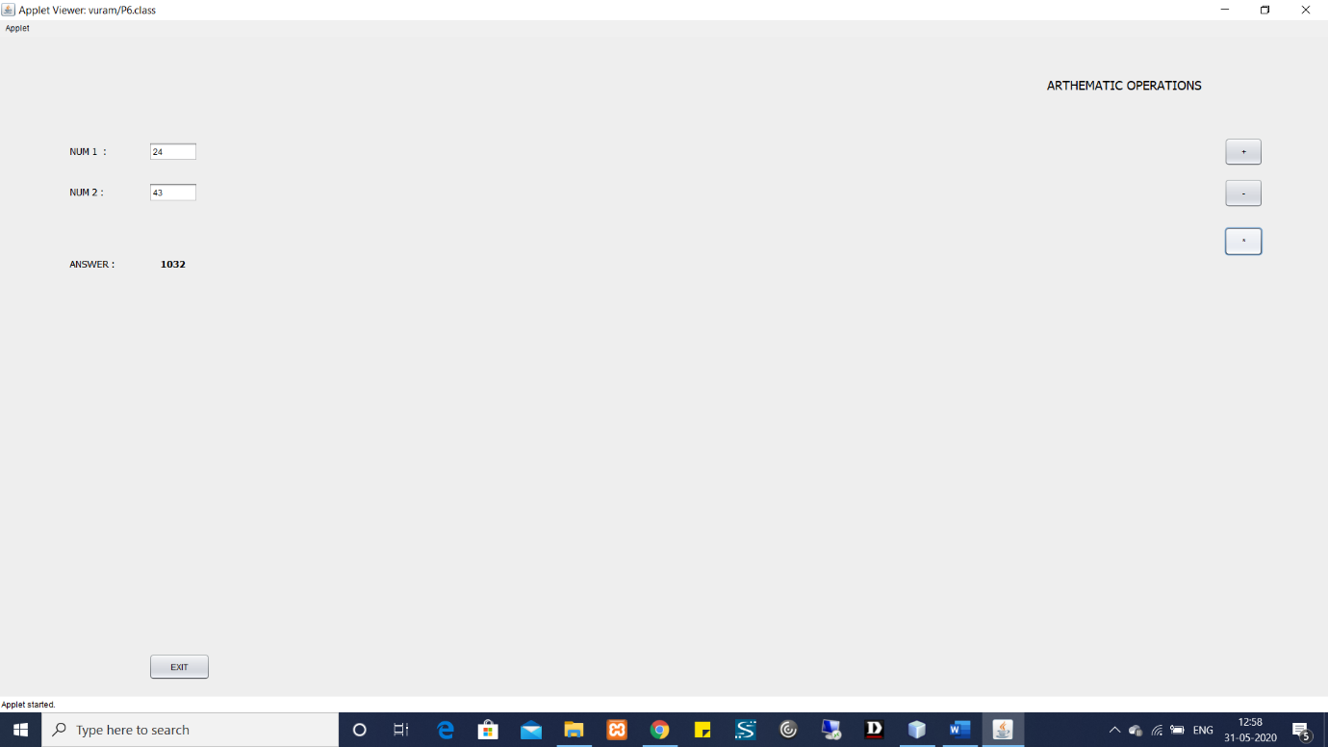

**Q-7:**

package vuram;

import java.awt.Color;

import java.awt.FlowLayout;

import java.awt.GridBagLayout;

import java.awt.GridLayout;

import java.awt.event.ActionEvent;

import java.awt.event.ActionListener;

import javax.swing.JButton;

import javax.swing.JFrame;

import javax.swing.JLabel;

import javax.swing.JPanel;

import javax.swing.JTextField;

class Start implements ActionListener

{

double a,b,c;

JFrame frame;

JTextField number1,number2;

JButton add,subtract,multiply,divide,modulo;

JLabel title,result;

public Start() {

setupFrame();

setUI();

add_UI();

add.addActionListener(this);

subtract.addActionListener(this);

multiply.addActionListener(this);

divide.addActionListener(this);

modulo.addActionListener(this);

}

private void setupFrame() {

frame = new JFrame();

frame.setSize(300, 300);

frame.setVisible(true);

frame.setTitle("Simple Calci");

frame.setLayout(new FlowLayout(1,30,30));

frame.setDefaultCloseOperation(JFrame.EXIT_ON_CLOSE);

}

private void setUI() {

number1 = new JTextField(10);

number2 = new JTextField(10);

add = new JButton("ADD");

subtract = new JButton("SUBTRACT");

multiply = new JButton("MULTIPLY");

divide = new JButton("DIVIDE");

modulo = new JButton("MODULOUS");

title = new JLabel("CALCULATOR");

title.setForeground(Color.BLUE);

result = new JLabel();

}

private void add_UI() {

frame.add(title);

frame.add(number1);

frame.add(number2);

frame.add(add);

frame.add(subtract);

frame.add(multiply);

frame.add(divide);

frame.add(modulo);

frame.add(result);

}

@Override

public void actionPerformed(ActionEvent ae) {

if(ae.getSource() == add)

{

a = Double.parseDouble(number1.getText());

b = Double.parseDouble(number2.getText());

c = a+b;

result.setText("The Answer is "+String.valueOf(c));

}

else if(ae.getSource() == subtract)

{

a = Double.parseDouble(number1.getText());

b = Double.parseDouble(number2.getText());

c = a-b;

result.setText("The Answer is "+String.valueOf(c));

}

else if(ae.getSource() == multiply)

{

a = Double.parseDouble(number1.getText());

b = Double.parseDouble(number2.getText());

c = a*b;

result.setText("The Answer is "+String.valueOf(c));

}

else if(ae.getSource() == divide)

{

a = Double.parseDouble(number1.getText());

b = Double.parseDouble(number2.getText());

c = a/b;

result.setText("The Answer is "+String.valueOf(c));

}

else

{

a = Double.parseDouble(number1.getText());

b = Double.parseDouble(number2.getText());

c = a%b;

result.setText("The Answer is "+String.valueOf(c));

}}}

public class P7 {

public static void main(String[] args) {

// TODO code application logic here

Start start = new Start();

}

}

**OUTPUT:**

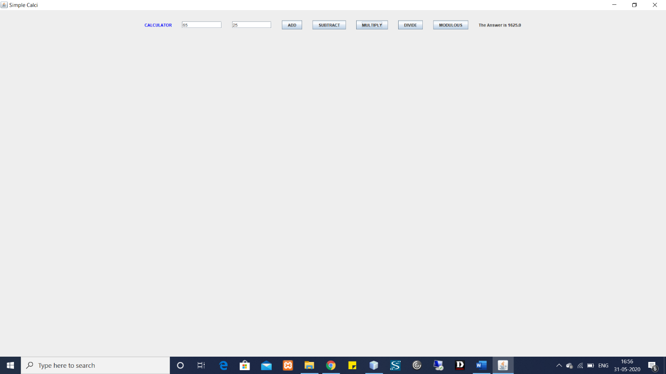

**Q-8:**

package vuram;

import java.awt.FlowLayout;

import java.awt.event.ActionEvent;

import java.awt.event.ActionListener;

import javax.swing.JButton;

import javax.swing.JFrame;

import javax.swing.JLabel;

import javax.swing.JTextField;

class Factorial implements ActionListener

{

JFrame frame;

JTextField number;

JButton result;

JLabel ans;

public Factorial() {

setFrame();

number = new JTextField(10);

result = new JButton("Find Factorial");

ans = new JLabel();

result.addActionListener(this);

frame.add(number);

frame.add(result);

frame.add(ans);

}

public void setFrame()

{

frame = new JFrame();

frame.setVisible(true);

frame.setSize(300,300);

frame.setLayout(new FlowLayout(1, 30, 30));

frame.setTitle("Factorial..!");

frame.setDefaultCloseOperation(JFrame.EXIT_ON_CLOSE);

}

@Override

public void actionPerformed(ActionEvent ae) {

int fact = 1,num;

num = Integer.parseInt(number.getText());

for(int i=1;i<=num;i++)

{

fact *= i;

}

ans.setText("The Factorial is "+String.valueOf(fact));

}

}

public class P8 {

public static void main(String[] args) {

Factorial factorial = new Factorial();

}}

**OUTPUT:**

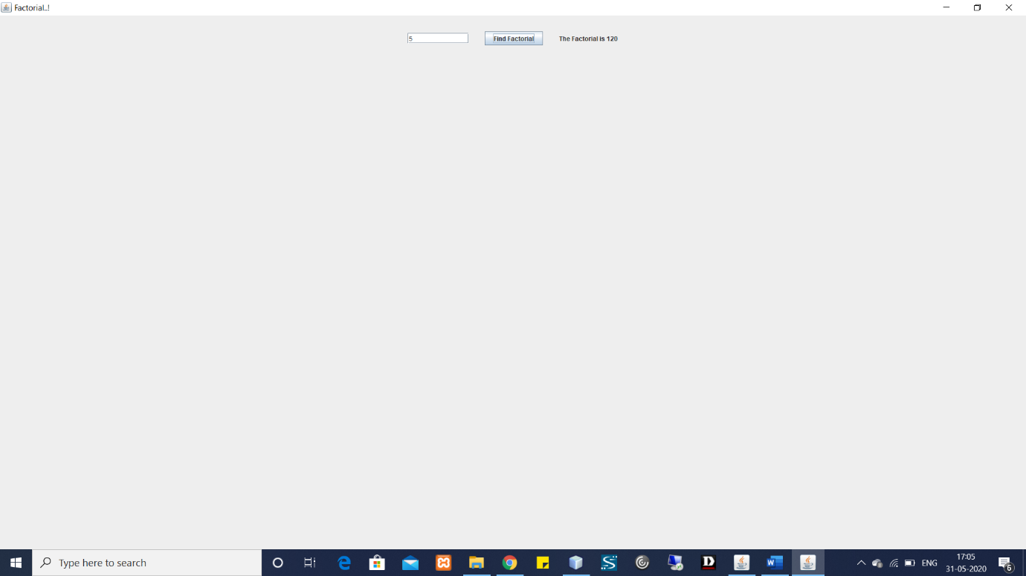

**Q-9:**

package vuram;

import java.applet.*;

import java.awt.event.*;

import java.awt.*;

public class P9 extends Applet implements ActionListener{

Label l1,l2;

TextField t1,t2;

Button b1;

public void init(){

l1=new Label("Enter a value: ");

t1=new TextField(10);

l2=new Label("Answer :");

t2=new TextField(10);

b1=new Button("Sum");

add(l1);

add(t1);

add(b1);

add(l2);

add(t2);

b1.addActionListener(this);

}

public void actionPerformed(ActionEvent x)

{

int n=Integer.parseInt(t1.getText());

int sum=0;

if(x.getSource()==b1)

{

for(int i=1;i<=n;i++)

sum=sum+i;

}

t2.setText(String.valueOf(sum));

}}

**OUTPUT:**

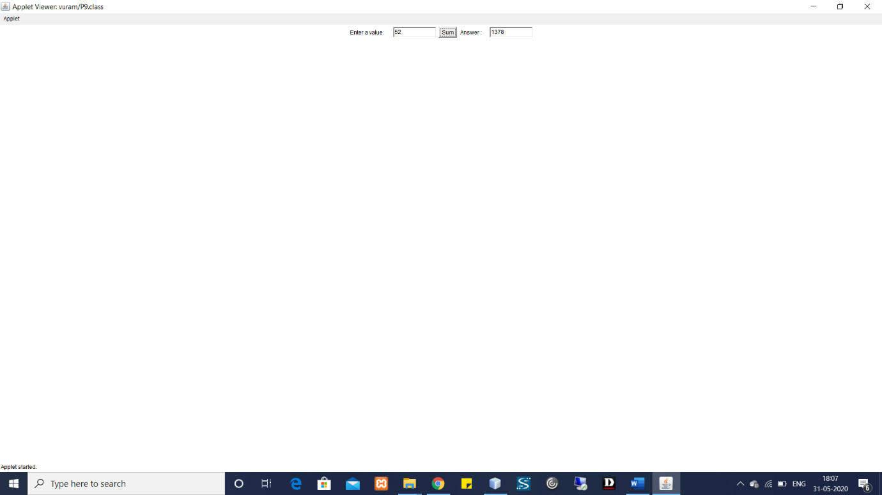

**Q-10:**

**Package-1:**

package EntertainmentSystem;

public class DvdPlayer {

public void On(){

System.out.println("The DVD player is on");

}

public void Off(){

System.out.println("The DVD player is off");

}

public void Play(){

System.out.println("The music is playing from the DVD Player");

}

public void Pause(){

System.out.println("The music is paused from the DVD player");

}

}

package EntertainmentSystem;

public class MusicSystem {

public void On(){

System.out.println("The music system is on");

}

public void Off(){

System.out.println("The music system is off");

}

public void Play(){

System.out.println("The music is playing from the music system");

}

public void Pause(){

System.out.println("The music is paused from the music system");

}}

**PACKAGE-2:**

package vuram;

import EntertainmentSystem.DvdPlayer;

import EntertainmentSystem.MusicSystem;

import java.util.Scanner;

public class P10 {

public static void main(String[] args){

Scanner in = new Scanner(System.in);

int n;

DvdPlayer dvd = new DvdPlayer();

MusicSystem MS = new MusicSystem();

System.out.println("Enter the choice \n1.DVD player \n2.Music system");

n = in.nextInt();

switch(n){

case 1:{

System.out.println("Enter the choice of operation \n1.on \t2.off \n3.play \t4.pause");

n = in.nextInt();

switch(n){

case 1:

{

dvd.On();

break;

}

case 2:

{

dvd.Off();;

break;

}

case 3:

{

dvd.Play();

break;

}

case 4:

{

dvd.Pause();

break;

}

}

break;

}

case 2:

{

System.out.println("Enter the choice of operation \n1.on \t2.off \n3.play \t4.pause");

n = in.nextInt();

switch(n){

case 1:

{

MS.On();

break;

}

case 2:

{

MS.Off();;

break;

}

case 3:

{

MS.Play();

break;

}

case 4: {

MS.Pause();

break;

} }

break;

} } }}

**OUTPUT:**

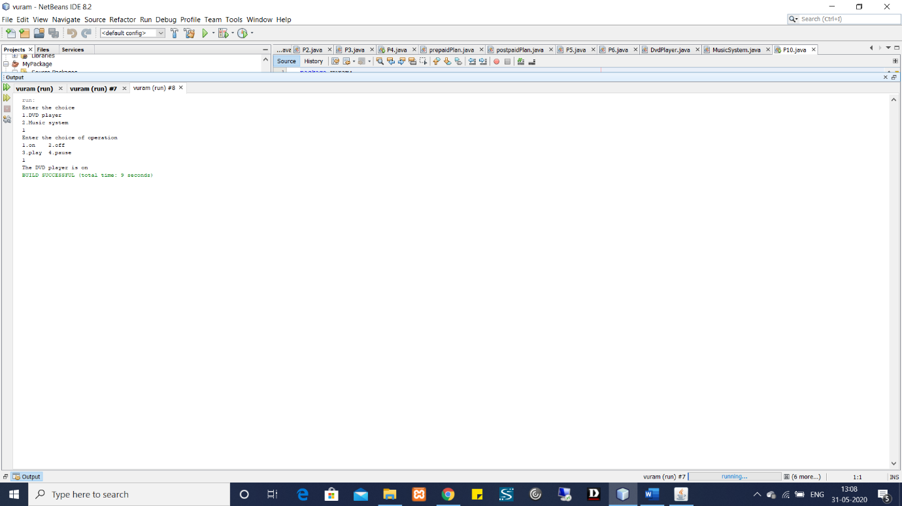

**Q-11:**

package vuram;

import java.lang.Thread;

import java.util.Scanner;

import java.util.concurrent.TimeUnit;

import java.util.logging.Level;

import java.util.logging.Logger;

class Account extends Thread{

private String AccountNumber,AccountName;

private int balance=0;

public Thread main ;

boolean back;

private Scanner in = new Scanner(System.in);

private String ThreadName;

Thread create = null,depo ,withd ,disp ;

Account(String name){

ThreadName = name;

}

@Override

public void run(){

int n;

System.out.println("Thread : "+ThreadName + " running");

System.out.println("Enter the choice\n1.create\t2.deposit\n3.withdraw\t4.display");

n = in.nextInt();

switch(n){

case 1:

{

try {

System.out.println("Starting new thread");

create = new Thread(new Runnable() {

@Override

public void run() {

//throw new UnsupportedOperationException("Not supported yet."); //To change body of generated methods, choose Tools | Templates.

AccountCreate();

}

});

create.setPriority(MAX_PRIORITY);

create.join();

create.start();

} catch (InterruptedException ex) {

System.out.println("Account creation thread interupted");

}

break;

}

case 2:

{

System.out.println("Starting deposit thread");

depo = new Thread(new Runnable() {

@Override

public void run() {

//throw new UnsupportedOperationException("Not supported yet."); //To change body of generated methods, choose Tools | Templates.

try {

if(create.isAlive()){

throw new Exception();

}

else{

AccountDeposit();

}

}catch(Exception e){

System.out.println("Either account is not created or the create thread is still alive");

Back();

} }

});

try {

depo.join();

} catch (Exception ex) {

}

depo.start();

break;

}

case 3:

{

System.out.println("Starting the withdraw thread");

withd = new Thread(new Runnable() {

@Override

public void run() {

//throw new UnsupportedOperationException("Not supported yet."); //To change body of generated methods, choose Tools | Templates.

try{

if(create.isAlive()){

throw new Exception();

}

else{

AccountWithdraw();

}

}catch(Exception e){

System.out.println("Either account is not created or the create thread is still alive");

Back();

}

}

});

try {

withd.join();

} catch (Exception e) {

}

withd.start();

break;

}

case 4:

{

System.out.println("Starting the display thread");

disp = new Thread(new Runnable() {

@Override

public void run() {

//throw new UnsupportedOperationException("Not supported yet."); //To change body of generated methods, choose Tools | Templates.

try{

if(create.isAlive()){

throw new Exception();

}

else {

AccountDisplay();

}

}catch(Exception e){

System.out.println("Either account is not created or the create thread is still alive");

Back();

}

}

});

try {

disp.join();

} catch (Exception e) {

}

disp.start();

}

}

try {

TimeUnit.SECONDS.sleep(1);

} catch (Exception e) {

System.out.println("Either account is not created or the create thread is still alive");

Back();

}

}

@Override

public void start(){

int n;

System.out.println("Starting the thread");

main = new Thread(this, ThreadName);

try {

main.join();

} catch (Exception e) {

System.out.println("t1.join exception");

}

main.start();

}

public void Back(){

this.back = false;

}@Override

public String toString(){

return "Account holder name : "+AccountName+"\nAccount number :"+AccountNumber+"\nBalance :"+balance+"\n";

}

public void AccountCreate(){

System.out.println("Enter the account holder name");

in.nextLine();

AccountName = in.nextLine();

System.out.println("Enter the account number");

AccountNumber = in.nextLine();

System.out.println("Initial Deposit --> rs.500\n");

balance = 500;

System.out.println("************** Account Created **************\n");

this.back = false;

//System.out.println("thread status : "+this.MT());

}

public void AccountDeposit(){

System.out.println("Enter the Ammount to be deposited");

int amt = in.nextInt();

balance = balance + amt;

System.out.println("Final balance : "+balance);

System.out.println("\n");

this.back = false;

}

public void AccountWithdraw(){

System.out.println("Enter the Ammount to be withdrawn");

int amt = in.nextInt();

try{

if(balance - amt < 500){

throw new Exception("Not sufficient fund available");

}

else{

balance = balance - amt;

}

}catch(Exception e){

System.out.println(e);

}

finally{

System.out.println("Final balance : "+balance+"\n");

}

this.back = false;

}

public void AccountDisplay(){

System.out.println("Displaying Account details");

System.out.print(this);

this.back = false;

}

}

public class P11 extends Thread {

int n;

@Override

public void run(){

Scanner in = new Scanner(System.in);

Account b1 = new Account("Thread - 1");

boolean flag = true;

while(flag){

b1.back = true;

System.out.println("1.Proceed \t2.exit");

n = in.nextInt();

switch(n)

{

case 1:

{

b1.start();

while(b1.back){

}

break;

}

case 2:

flag = false;

break;

}

}

}

@Override

public void start(){

Thread t1 = new Thread(this);

t1.start();

}

public static void main(String[] args) throws InterruptedException{

P11 obj = new P11();

obj.start();

}}

**OUTPUT:**

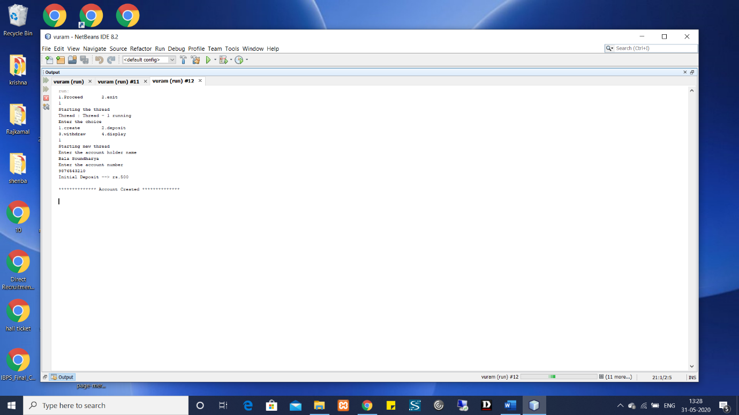

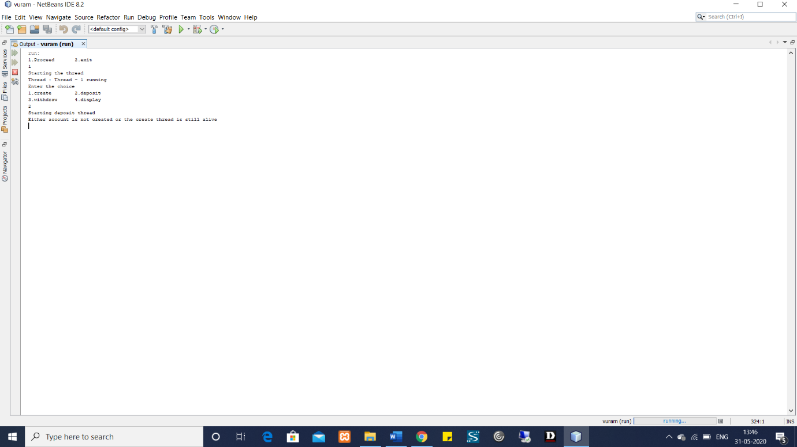

**Q-12:**

package vuram;

import java.io.DataInputStream;

import java.io.DataOutputStream;

import java.io.File;

import java.io.FileInputStream;

import java.io.FileOutputStream;

import java.io.Serializable;

import java.util.Scanner;

import org.omg.CORBA.Any;

import org.omg.CORBA.Object;

import org.omg.CORBA.TypeCode;

public class P4 {

static String Eno,E_name,Dept,dob,doj;

static String Employee_datail;

static int salary;

public static void main(String[] args) throws Exception{

Scanner s = new Scanner(System.in);

System.out.println("Enter Employee Details");

Eno = s.nextLine();

E_name = s.nextLine();

Dept = s.nextLine();

dob = s.nextLine();

doj = s.nextLine();

salary = s.nextInt();

Employee_datail = Eno+" \n"+E_name+" \n"+Dept+" \n"+dob+" \n"+doj+" \n"+salary+" \n";

write();

read();

}

private static void write() throws Exception{

File file = new File(Eno+".txt");

FileOutputStream fos = new FileOutputStream(file);

DataOutputStream dos = new DataOutputStream(fos);

dos.writeUTF(Employee_datail);

}

private static void read() throws Exception {

File file = new File(Eno+".txt");

FileInputStream fis = new FileInputStream(file);

DataInputStream dis = new DataInputStream(fis);

String detail = dis.readUTF();

System.out.println(detail);

}

}

**OUTPUT:**



**Q-13:**

package vuram;

import java.io.*;

public class P13 {

public static void main(String[] args) throws IOException{

FileReader in = null;

FileWriter out = null;

try {

in = new FileReader("C:\\Users\\KRISHSHENBA\\Desktop\\input.txt");

out = new FileWriter("C:\\Users\\KRISHSHENBA\\Desktop\\output.txt");

int c;

while ((c = in.read()) != -1) {

out.write(c);

}

}finally {

if (in != null) {

in.close();

}

if (out != null) {

out.close();

}}}}

**OUTPUT:**

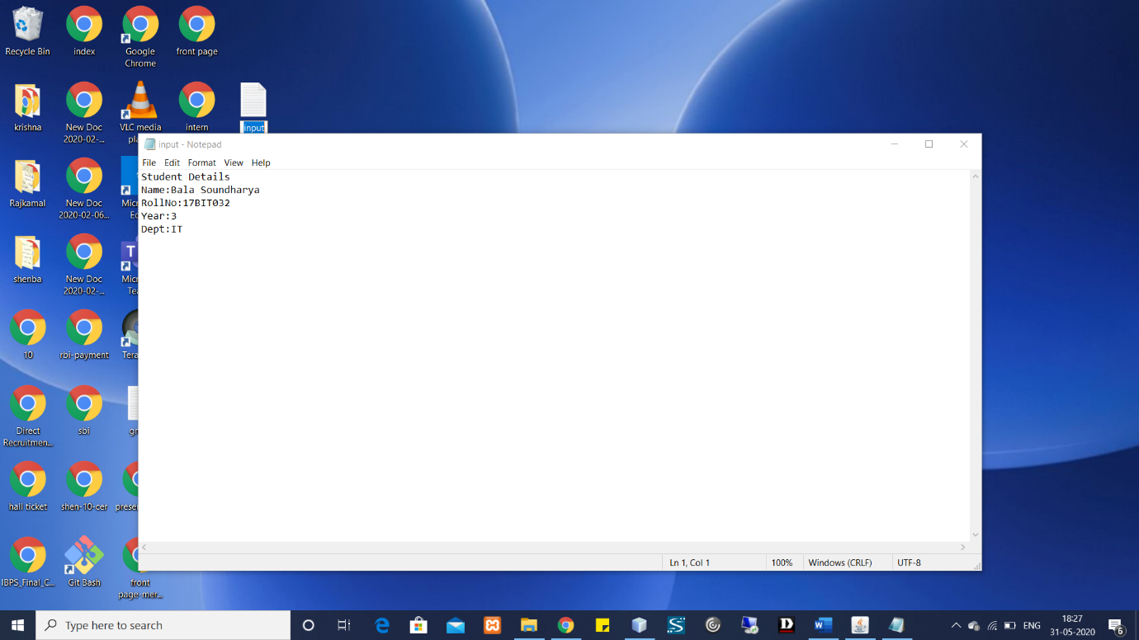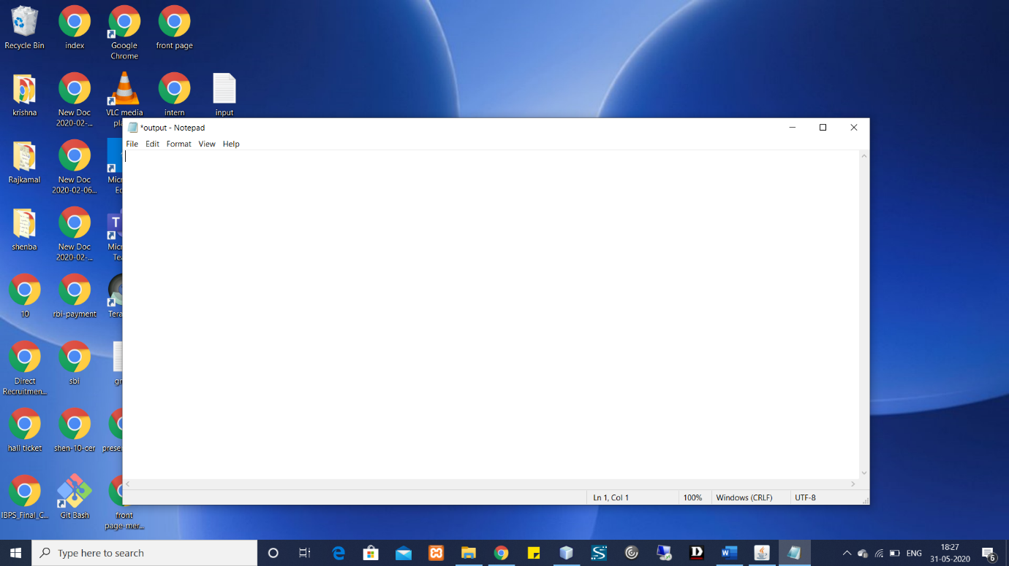

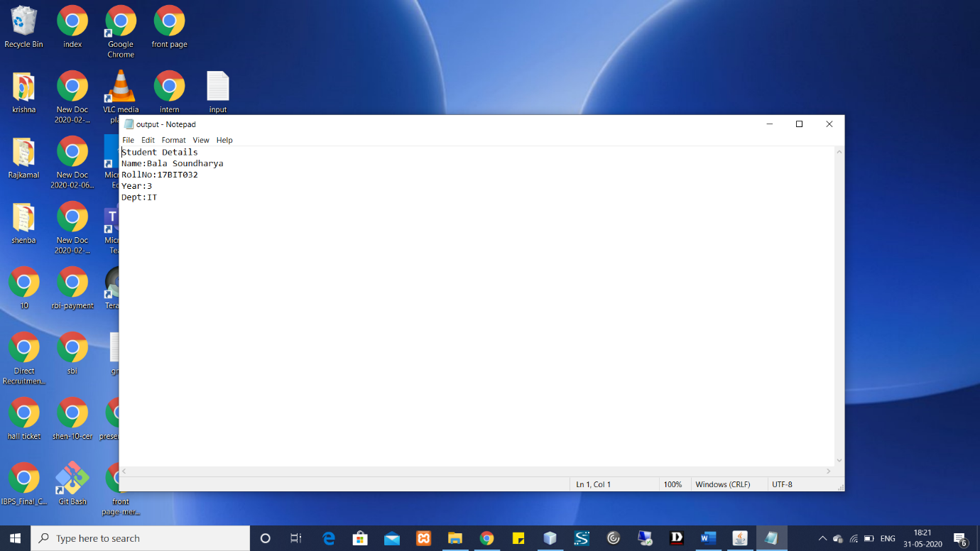

**Q-14:**

package vuram;

import java.util.*;

import java.lang.*;

class Employee{

private String Emp_name,Emp_id,Emp_desg;

private double salary;

public Employee(String Emp_name, String Emp_id, String Emp_desg, double salary) {

this.Emp_name = Emp_name;

this.Emp_id = Emp_id;

this.Emp_desg = Emp_desg;

this.salary = salary;

}

public String getEmp_name() {

return Emp_name;

}

public String getEmp_id() {

return Emp_id;

}

public String getEmp_desg() {

if(Emp_desg.equalsIgnoreCase("Manager")){

salary=salary*0.2+salary;

}

if(Emp_desg.equalsIgnoreCase("Clerk")){

Emp_desg="Analyst";

}

return Emp_desg;

}

public double getSalary() {

return salary;

}

public void setEmp_name(String Emp_name) {

this.Emp_name = Emp_name;

}

public void setEmp_id(String Emp_id) {

this.Emp_id = Emp_id;

}

public void setEmp_desg(String Emp_desg) {

this.Emp_desg = Emp_desg;

}

public void setSalary(double salary) {

this.salary = salary;

}

}

public class Pr14 {

public static void main(String args[]){

String Emp_name,Emp_id,Emp_desg;

double Emp_salary;

Employee arr[] = new Employee[5];

for(int i=0;i<arr.length;i++)

{

Scanner s = new Scanner(System.in);

System.out.println("Enter Employee Name: ");

Emp_name = s.nextLine();

System.out.println("Enter Employee Id: ");

Emp_id = s.nextLine();

System.out.println("Enter Employee Desgnation: ");

Emp_desg = s.nextLine();

System.out.println("Enter Employee Salary: ");

Emp_salary = s.nextDouble();

arr[i]=new Employee( Emp_name, Emp_id,Emp_desg, Emp_salary);

System.out.println("Output:");

System.out.println(arr[i].getEmp_name());

System.out.println(arr[i].getEmp_id());

System.out.println(arr[i].getEmp_desg());

System.out.println(arr[i].getSalary());

} }}

**OUTPUT:**

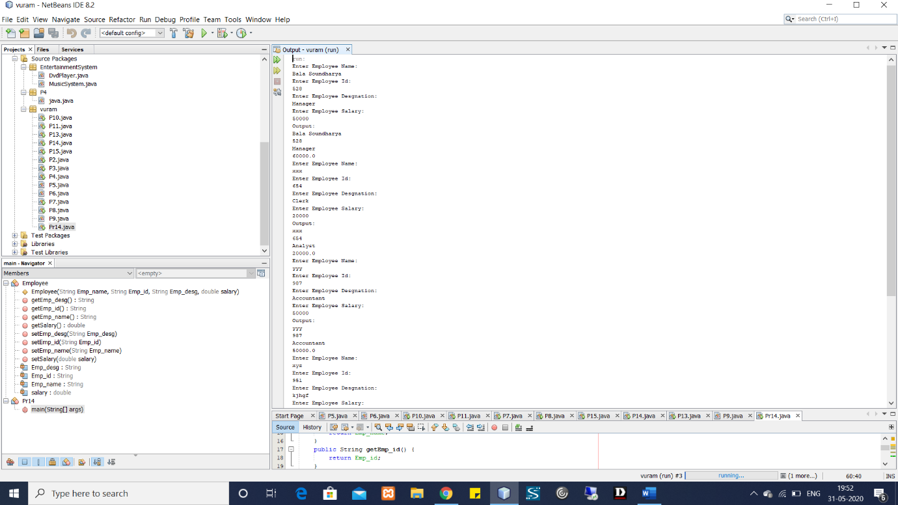

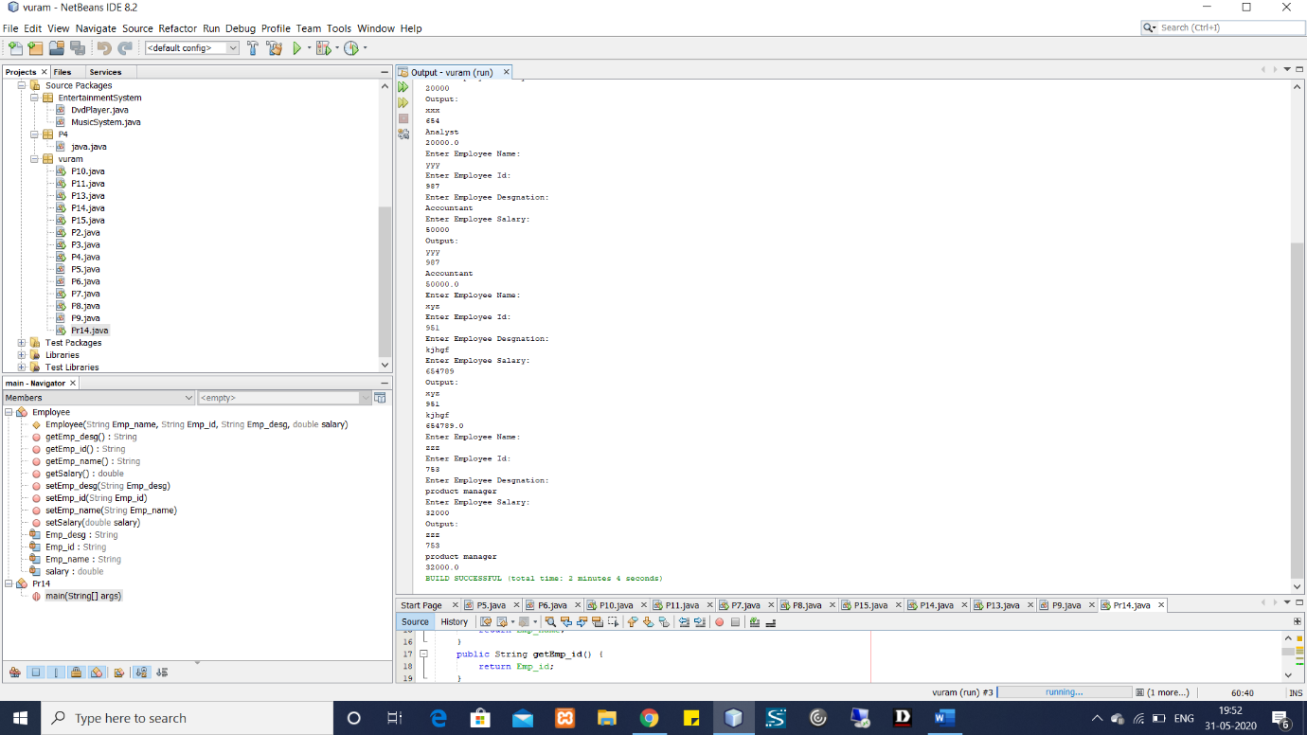

**Q-15:**

package vuram;

import java.util.*;

abstract class Pr15{

String name;

String address;

}

class FulltimeStaff extends Pr15{

String dept;

double salary;

public FulltimeStaff(String dept,double salary,String name,String address){

this.dept=dept;

this.salary=salary;

this.name=name;

this.address=address;

}

public void displaydetails()

{

System.out.println("Emp Name: "+name);

System.out.println("Emp Address: "+address);

System.out.println("Emp Dept: "+dept);

System.out.println("Emp salary: "+salary);

}

}

class ParttimeStaff extends Pr15{

String name;

String address;

double noofhours;

int rateperhour;

public ParttimeStaff(String name,String address,double noofhours,int rateperhour){

this.noofhours=noofhours;

this.rateperhour=rateperhour;

}

public void displaydetails()

{

System.out.println("Emp Name: "+name);

System.out.println("Emp Address: "+address);

System.out.println("Emp no. of Hours Work: "+noofhours);

System.out.println("Rate Per hous: ₹"+rateperhour);

}

}

public class program{

static Scanner s =new Scanner(System.in);

public static void main(String args[]){

int options,n;

System.out.println("1.Full Time Staff \n2.Part Time Staff");

options = s.nextInt();

if(options == 1)

{

System.out.println("Enter the number of objects");

n = s.nextInt();

create_n_objects(n,1);

}

else

{

System.out.println("Enter the number of objects");

n = s.nextInt();

create_n_objects(n,2);

}

}

private static void create_n_objects(int n, int i) {

if(i==1)

{

FulltimeStaff[] obj = new FulltimeStaff[n];

for(int j=0;j<n;j++)

{

System.out.println("Enter Employee Name");

s.nextLine();

String name = s.nextLine();

System.out.println("Enter the address");

String address=s.nextLine();

System.out.println("Enter Dept");

String dept = s.nextLine();

System.out.println("Enter the salary");

double salary = s.nextInt();

obj[j] = new FulltimeStaff(dept, salary, name, address);

}

for(int j=0;j<n;j++)

{

obj[j].displaydetails();

}

}

else

{

ParttimeStaff[] obj = new ParttimeStaff[n];

for(int j=0;j<n;j++)

{

System.out.println("Enter Employee Name");

s.nextLine();

String name = s.nextLine();

System.out.println("Enter Employee Address");

String address = s.nextLine();

System.out.println("Enter no of hours");

int noofhours = s.nextInt();

System.out.println("Enter the rate per hour");

int rateperhour = s.nextInt();

obj[j] = new ParttimeStaff(name,address,noofhours, rateperhour);

}

for(int j=0;j<n;j++)

{

obj[j].displaydetails();

}

}

}

}

**OUTPUT:**

